# Distributed Computing EXP-2

## Name:Atharva Pawar

**Roll NO:9427**

**Batch:D**

# Implement an RPC client and server

## Code:

//client.java

import java.io.*; import java.net.*;

public class client{

public static void main(String[] args) { if (args.length != 3) {

System.out.println("Usage: java Example <hostname> <num1> <num2>"); return;

}

String hostname = args[0];

int num1 = Integer.parseInt(args[1]); int num2 = Integer.parseInt(args[2]);

try {

// Create a socket connection to the server Socket socket = new Socket(hostname, 8888);

// Create ObjectOutputStream and ObjectInputStream for communication ObjectOutputStream out = new ObjectOutputStream(socket.getOutputStream());

// Send the numbers to the server out.writeInt(num1); out.writeInt(num2);

out.flush();

// Receive the result from the server int result = in.readInt();

System.out.println("Result of addition: " + result);

// Close the connection socket.close();

} catch (IOException e) { e.printStackTrace();

}

}

}

//server.java

import java.io.*; import java.net.*;

public class server {

public static void main(String[] args) { try {

// Create a ServerSocket

ServerSocket serverSocket = new ServerSocket(8888); System.out.println("Server started");

while (true) {

// Accept client connections

Socket socket = serverSocket.accept(); System.out.println("Client connected");

// Create ObjectInputStream and ObjectOutputStream for communication

ObjectOutputStream out = new ObjectOutputStream(socket.getOutputStream());

// Read numbers from client int num1 = in.readInt();

int num2 = in.readInt();

// Calculate the result

int result = num1 + num2;

// Send the result back to the client out.writeInt(result);

out.flush();

// Close the connection socket.close();

System.out.println("Client disconnected");

}

} catch (IOException e) { e.printStackTrace();

}

}

}

## Output:

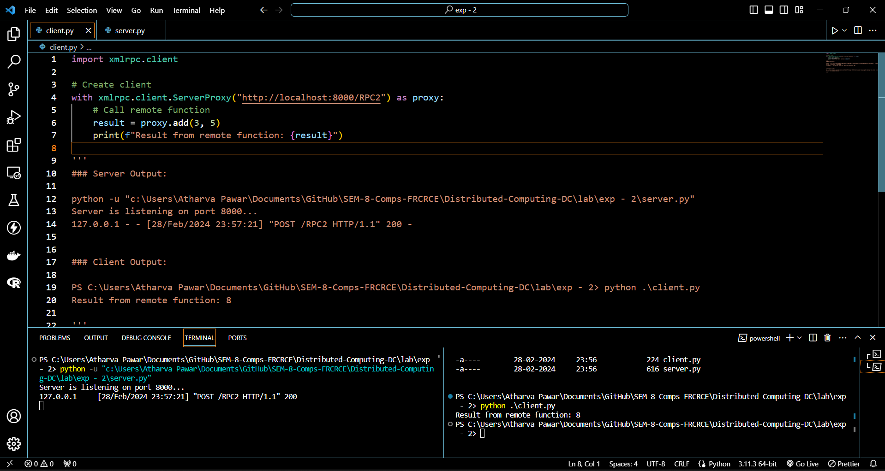

POSTLAB

1. In which category of communication, RPC be included?
2. What are stubs? What are the different ways of stub generation?
3. What is binding?
4. Name the transparencies achieved through stubs

